34.111: a) From Figure 34.56, we define 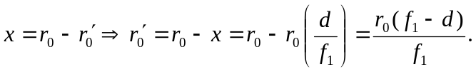
b) 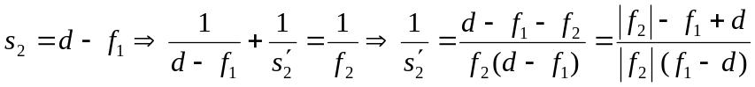
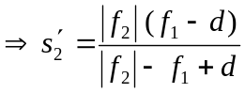
c) 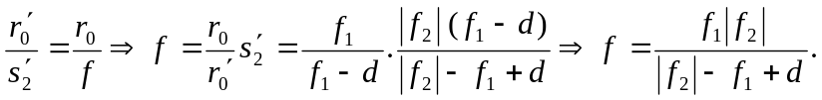
d) 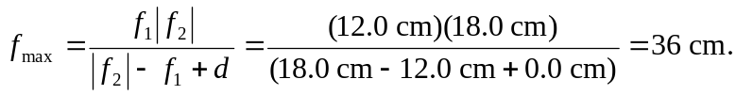
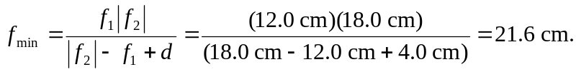
If the effective focal length is 30 cm, then the separation can be calculated:
